Timkin Requested app for relocation.

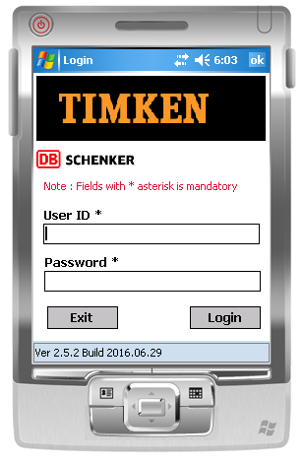-

**Valid user /login**

user1 / password1

user2 / password2

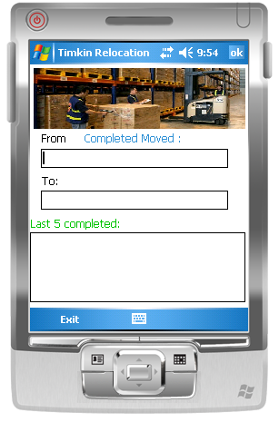

Scan the Location_from and Location_to

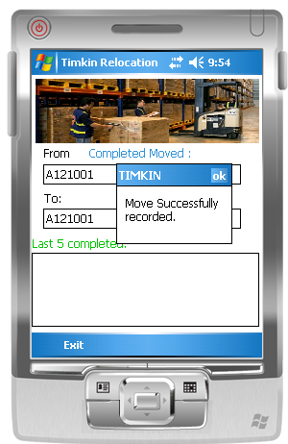

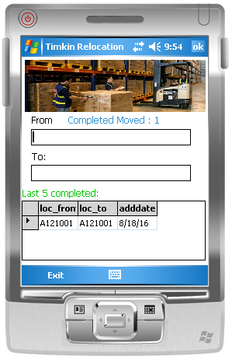

After successfully inserted into the database the screen is refresh with the last 5 completed for the user.

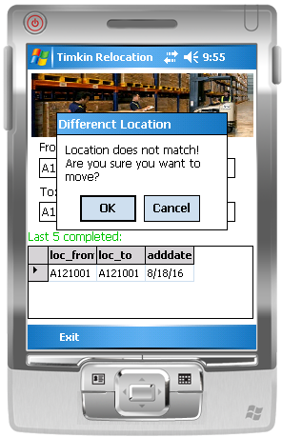

Some validations when Location_From is not the same as location_to

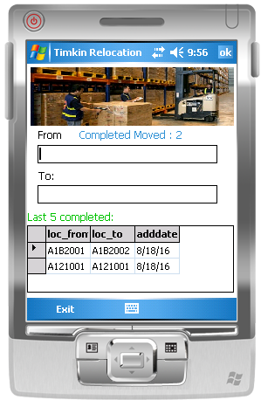

If yes is selected. Otherwise system will ask to rescan.